# **Creating Amazon EC2 Instances**

## **Lab overview**

AWS provides multiple ways to launch Amazon Elastic Compute Cloud (Amazon EC2) instance.

In this lab, you use the AWS Management Console to launch an EC2 instance and then use it as a bastion host to launch another EC2 instance, which will be a web server. You use EC2 Instance Connect to securely connect to the bastion host and use the AWS Command Line Interface (AWS CLI) to launch a web server instance.

The following diagram illustrates the final architecture that you will build:

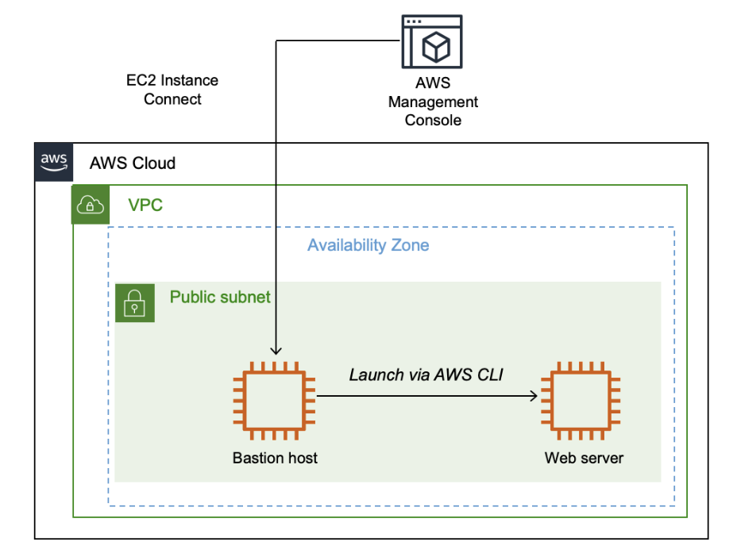

If you have time, you can follow the steps in the optional challenge sections to troubleshoot some issues with EC2 instances.

## **Objectives**

After completing this lab, you should be able to do the following:

* Launch an EC2 instance by using the AWS Management Console.
* Connect to the EC2 instance by using EC2 Instance Connect.
* Launch an EC2 instance by using the AWS CLI.

## **Duration**

This lab will require approximately **45 minutes** to complete.

## **Accessing the AWS Management Console**

1. At the top of these instructions, choose Start Lab to launch the lab.

A **Start Lab** panel opens displaying the lab status.

1. Wait until the message "Lab status: ready" appears, and then choose **X** to close the **Start Lab** panel.
2. Next to Start Lab, choose AWS to open the AWS Management Console on a new browser tab. The system automatically signs you in.

**Tip** If a new browser tab does not open, a banner or icon at the top of your browser will indicate that your browser is preventing the site from opening pop-up windows. Choose the banner or icon, and choose **Allow pop-ups**.

1. Arrange the AWS Management Console so that it appears alongside these instructions.

**Important:** Do not change the lab Region unless specifically instructed to do so.

## **Task 1: Launching an EC2 Instance by using the AWS Management Console**

In this task, you launch an EC2 instance by using the AWS Management Console. The instance will be a bastion host from which you can use the AWS CLI.

1. On the **AWS Management Console**, in the **Search** bar, enter and choose EC2 to open the **Amazon EC2 Management Console**.
2. From the **Launch instance** dropdown list, choose **Launch instance** to open the **Launch an instance** menu.

### **Step 1: Choose name and tags**

You use tags to categorize your AWS resources in different ways, such as by purpose, owner, or environment. This categorization is useful when you have many resources of the same type; you can quickly identify a specific resource by its tags. Each tag consists of a *key* and a *value*, both of which you define.

When you name your instance, AWS creates a key-value pair. The key for this pair is **Name**, and the value is the name that you enter for your EC2 instance.

1. In the **Name and tags** section, for **Name**, enter Bastion host

### **Step 2: Choose an AMI**

In this step, you choose an Amazon Machine Image (AMI). An AMI includes the following:

* A template for the root volume for the instance (for example, an operating system or an application server with applications)
* Launch permissions that control which AWS accounts can use the AMI to launch instances
* A block device mapping that specifies the volumes to attach to the instance when it is launched

The **Quick Start** list contains the most commonly used AMIs. You can also create your own AMI or select an AMI from the AWS Marketplace, an online store where you can sell or buy software that runs on AWS.

Your bastion host will use Amazon Linux 2.

1. In the **Application and OS Images (Amazon Machine Image)** section, for **Quick Start**, confirm that **Amazon Linux** is selected. Keep this selection.

**Note:** This option corresponds to Amazon Linux 2 AMI (HVM) as indicated in the **Description**.

### **Step 3: Choose an instance type**

In this step, you choose an instance type, which determines the resources that will be allocated to your EC2 instance. Each instance type allocates a combination of virtual CPU, memory, disk storage, and network performance.

Instance types are divided into families, such as compute optimized, memory optimized, and storage optimized. The name of the instance type includes a family identifier, such as T3 and M5. The number indicates the generation of the instance, so M5 is newer than M4.

Your application uses a t3.micro instance type, which is a small instance that can burst above baseline performance when it is busy. It is suitable for development and testing purposes and for applications that have bursty workloads.

1. From the **Instance type** dropdown list, search for and choose **t3.micro**.

### **Step 4: Configure a key pair**

Amazon EC2 uses public key cryptography to encrypt and decrypt login information. To log in to your instance, you must create a key pair, specify the name of the key pair when you launch the instance, and provide the private key when you connect to the instance.

In this lab, you use EC2 Instance Connect to log in to your instance, so you do not require a key pair.

1. In the **Key pair (login)** section, from the **Key pair name - required** dropdown list, choose **Proceed without key pair (Not recommended)**.

### **Step 5: Configure the network settings**

You use this pane to configure networking settings.

The virtual private cloud (VPC) indicates which VPC you want to launch the instance into. You can have multiple VPCs, including different ones for development, testing, and production.

You launch the instance in a public subnet within the Lab VPC network.

1. In the **Network settings** section, choose **Edit**.
2. From the **VPC - *required*** dropdown list, choose **Lab VPC**.

The Lab VPC was created using an AWS CloudFormation template during the setup process of your lab. This VPC includes one public subnet.

1. In the **Subnet** dropdown list, notice that **Public Subnet** is selected by default. Keep this default setting.
2. In the **Auto-assign public IP** dropdown list, notice that **Enable** is selected by default. Keep this default setting.
3. In the **Firewall (security groups)** section, notice that **Create security group** is selected. Configure the following options:
   * For **Security group name - *required*** enter Bastion security group
   * For **Description - *required*** enter Permit SSH connections

A security group acts as a virtual firewall that controls the traffic for one or more instances. When you launch an instance, you associate one or more security groups with the instance. You add rules to each security group that allow traffic to or from its associated instances. You can modify the rules for a security group at any time; the new rules are automatically applied to all instances that are associated with the security group.

### **Step 6: Add storage**

You can use this step to add additional Amazon Elastic Block Store (Amazon EBS) disk volumes and configure their size and performance.

You launch the EC2 instance using a default 8 gibibyte (GiB) disk volume. This is your root volume (also known as a boot volume).

1. In the **Configure storage** pane, keep the default storage configuration.

### **Step 7: Configure advanced details**

1. Expand the **Advanced details** pane.
2. From **IAM instance profile** dropdown list, choose **Bastion-Role**.

The Bastion-Role profile grants permission to applications running on the instance to make requests to the Amazon EC2 service. This association of Role is required for the second half of this lab, where you use the AWS CLI to communicate with the Amazon EC2 service.

1. Leave the default settings for all the other values.

### **Step 8: Launch an EC2 instance**

Now that you have configured your EC2 instance settings, it is time to launch your instance.

1. In the **Summary** section, review the instance configuration details displayed, and choose **Launch instance**.
2. Choose **View all instances**.

## **Task 2: Logging in to the bastion host**

In this task, you use EC2 Instance Connect to log in to the bastion host that you just created.

1. On the **EC2 Management Console**, from the list of EC2 instances displayed, choose the check box for the **bastion host** instance.
2. Choose **Connect**.
3. On the **EC2 Instance Connect** tab, choose **Connect** to connect to the bastion host.

**Note:** If you prefer to use an SSH client to connect to the EC2 instance, see the guidance to [Connect to your Linux instance](https://docs.aws.amazon.com/AWSEC2/latest/UserGuide/AccessingInstances.html).

Now that you are connected to the bastion host, you can use the AWS CLI to call AWS services.

## **Task 3: Launching an EC2 instance using the AWS CLI**

In this task, you launch an EC2 instance using the AWS CLI. With the AWS CLI, you can automate the provisioning and configuration of AWS resources. Launching EC2 instance by using a CLI command is similar to launching an instance using the console. When you use a CLI command, you need to supply all the parameters to the command to successfully run it and launch.

You can enter this information or retrieve it from the environment using CLI commands (for example, the AMIId, SubnetId, and SecurityGroupId commands in this scenario).

You need to configure the new EC2 instance as a web server. In addition to providing the parameters previously mentioned, you also need to use the user data script to install the Apache web server.

You run the scripts or commands provided in the following section in the EC2 Instance Connect session.

### **Step 1: Retrieve the AMI to use**

One of the parameters required when launching an instance is the AMI, which populates the boot disk of the instance. AWS continually patches and updates AMIs, so it is recommended to always use the latest AMI when launching instances.

You use AWS Systems Manager Parameter Store to retrieve the ID of the most recent Amazon Linux 2 AMI. AWS maintains a list of standard AMIs in Parameter Store, which makes it possible to automate this task.

1. Run the following script in your EC2 Instance Connect session:

#Set the Region

AZ=`curl -s <http://169.254.169.254/latest/meta-data/placement/availability-zone`export> AWS_DEFAULT_REGION=${AZ::-1}#Retrieve latest Linux AMIAMI=$(aws ssm get-parameters --names /aws/service/ami-amazon-linux-latest/amzn2-ami-hvm-x86_64-gp2 --query 'Parameters[0].[Value]' --output text)echo $AMI

**Script explanation**

* The script retrieves the Availability Zone for the running instance using instance metadata.
* The script retrieves the Region from the Availability Zone and exports it into the environment for subsequent use.
* The script calls the AWS Systems Manager (indicated with the ssm command) and uses the get-parameters command to retrieve the AMI ID from Parameter Store.
* The AMI requested was for Amazon Linux 2 (which is the same as the one used for bastion host).
* The AMI ID has been stored in an environment variable called AMI.

If your EC2 Instance Connect session disconnects, it will lose the information stored in the environment variables. Refresh your browser to reconnect. If you do so, you will need to re-run all of the steps in this task, starting with the commands in this step, to obtain the AMI ID.

### **Step 2: Retrieve the subnet to use**

You launch the new instance in the public subnet. When launching an instance, you can specify the subnet ID.

1. To retrieve the subnet ID for the public subnet, run the following command:

SUBNET=$(aws ec2 describe-subnets --filters 'Name=tag:Name,Values=Public Subnet' --query Subnets[].SubnetId --output text)

echo $SUBNET

This script runs the aws ec2 command with the describe-subnets subcommand to retrieve the subnet ID of the subnet named **Public Subnet**.

### **Step 3: Retrieve the security group to use**

This lab includes a web security group, which allows inbound HTTP requests.

1. Run the following command:

SG=$(aws ec2 describe-security-groups --filters Name=group-name,Values=WebSecurityGroup --query SecurityGroups[].GroupId --output text)

echo $SG

The script runs the aws ec2 command with the describe-security-groups subcommand to retrieve the security group ID of the web security group.

### **Step 4: Download a user data script**

In this step, you launch an instance that acts as a web server. To install and configure the web server, you provide a user data script that automatically runs when the instance launches.

1. To download the user data script, run the following command:

wget <https://aws-tc-largeobjects.s3.us-west-2.amazonaws.com/CUR-TF-100-RSJAWS-1-23732/171-lab-JAWS-create-ec2/s3/UserData.txt>

1. To view the contents of the script, run the following command:

cat UserData.txt

The script does the following:

* Installs a web server
* Downloads a .zip file containing the web application
* Installs the web application

### **Step 5: Launch the instance**

You now have all the necessary information required to launch the web server instance.

1. Run the following command:

INSTANCE=$(\

aws ec2 run-instances \--image-id $AMI \--subnet-id $SUBNET \--security-group-ids $SG \--user-data <file:///home/ec2-user/UserData.txt> \--instance-type t3.micro \--tag-specifications 'ResourceType=instance,Tags=[{Key=Name,Value=Web Server}]' \--query 'Instances[*].InstanceId' \--output text \)echo $INSTANCE

The run-instances command launches a new instance using these parameters:

* **Image:** Uses the AMI value obtained earlier from Parameter Store
* **Subnet:** Specifies the public subnet retrieved earlier and, by association, the VPC in which to launch the instance
* **Security group:** Uses the web security group retrieved earlier, which permits HTTP access
* **User data:** References the user data script that you downloaded, which installs the web application
* **Instance type:** Specifies the type of instance to launch
* **Tags:** Assigns a name tag with the value of **Web Server**

The query parameter specifies that the command should return the instance ID once the instance is launched.

The output parameter specifies that the output of the command should be in text. Other output options are json and table.

**Note:** The ID of the new instance has been stored in the INSTANCE environment variable.

### **Step 6: Wait for the instance to be ready**

You can monitor the status of the instance by using the AWS Management Console or by querying the status by using the AWS CLI.

1. Run the following command:

aws ec2 describe-instances --instance-ids $INSTANCE

All information related to the instance is displayed in JSON format. This information includes the instance status.

You can retrieve specific information by using the query parameter.

1. Run the following command:

aws ec2 describe-instances --instance-ids $INSTANCE --query 'Reservations[].Instances[].State.Name' --output text

This command is the same as the command in the previous step, but rather than displaying all information about the instance, this command displays only the name of the instance state.

This command displays a status of *pending* or *running*.

Run this command again until it returns a status of *running*.

### **Step 7: Test the web server**

You can now test that the web server is working. You can retrieve a URL to the instance through the AWS CLI.

1. Run the following command:

aws ec2 describe-instances --instance-ids $INSTANCE --query Reservations[].Instances[].PublicDnsName --output text

This command returns the public IPv4 Domain Name System (DNS) name of the instance.

1. Copy the DNS name that is displayed. It should be similar to the following:

ec2-35-11-22-33.us-west-2.compute.amazonaws.com

1. Paste the DNS name into a new web browser tab, and then press Enter.

A web page should be displayed, which demonstrates that the web server was successfully launched and configured.

You can also see the instance on the Amazon EC2 management console.

1. Return to the web browser tab containing the Amazon EC2 management console. In the left navigation pane, choose **Instances**, and choose refresh.

The list should now include the **Web Server** instance that you launched by using the CLI command.

As you see in this task, the AWS CLI makes it possible to programmatically access and control AWS services. You can place these commands in a script and run them as a standard process to deploy consistent, reliable infrastructure with minimal scope for human error.

**Which method should you use?**

* Launch from the management console when you quickly need to launch a one-off or temporary instance.
* Launch by using a script when you need to automate the creation of an instance in a repeatable, reliable manner.
* Launch by using CloudFormation when you want to launch related resources together.

## **Optional challenge 1: Connect to an EC2 instance**

This challenge is optional and is provided in case you have lab time remaining.

In this challenge, you troubleshoot the security configuration of an instance called **Misconfigured Web Server**.

1. The following are your tasks:
   * Try to connect to the **Misconfigured Web Server** instance by using EC2 Instance Connect.
   * Diagnose why this does not work, and fix the misconfiguration.

At the end of the lab, your instructor will ask you the following questions:

* + What was the problem?
  + What did you do to fix the problem?

## **Optional challenge 2: Fix the web server installation**

In this challenge, you troubleshoot the web server installation on the **Misconfigured Web Server** instance:

1. The following are your tasks:
   * Retrieve the public IPv4 DNS name of the **Misconfigured Web Server** instance.
   * In a new browser window, try to open the public IPv4 DNS name that you retrieved.
   * Diagnose why this does not work, and fix the misconfiguration.

At the end of the lab, your instructor will ask you the following questions:

* + What was the problem?
  + What did you do to fix the problem?

## **Conclusion**

Congratulations! You now have successfully done the following:

* Launched an EC2 instance by using AWS Management Console
* Connected to the instance by using EC2 Instance Connect
* Launched an EC2 instance by using the AWS CLI

## **Lab complete**

Congratulations! You have completed the lab.

1. At the top of this page, choose End Lab and then choose **Yes** to confirm that you want to end the lab.

A panel appears indicating that "You may close this message box now. Lab resources are terminating."

1. To close the **End Lab** panel, choose the **X** in the upper-right corner.

## **Additional resources**

* [Launch Your Instance](https://docs.aws.amazon.com/AWSEC2/latest/UserGuide/LaunchingAndUsingInstances.html)
* [Connect to Your Linux instance Using EC2 Instance Connect](https://docs.aws.amazon.com/AWSEC2/latest/UserGuide/Connect-using-EC2-Instance-Connect.html)
* [Amazon EC2 - User Data and Shell Scripts](https://docs.aws.amazon.com/AWSEC2/latest/UserGuide/user-data.html)
* [AWS Command Line Interface (AWS CLI)](https://docs.aws.amazon.com/cli/index.html)

For more information about AWS Training and Certification, see [AWS Training and Certification](http://aws.amazon.com/training/).

*Your feedback is welcome and appreciated.*

If you would like to share any suggestions or corrections, please provide the details in our [AWS Training and Certification Contact Form](https://support.aws.amazon.com/#/contacts/aws-training).

*© 2023, Amazon Web Services, Inc. or its affiliates. All rights reserved. This work may not be reproduced or redistributed, in whole or in part, without prior written permission from Amazon Web Services, Inc. Commercial copying, lending, or selling is prohibited.*